Kestrel Ridge Wind Farm – Site Overview
Key facts, layout, contracts and contacts
David Chen · 14 July 2026 · KR-OPS-GEN-0001
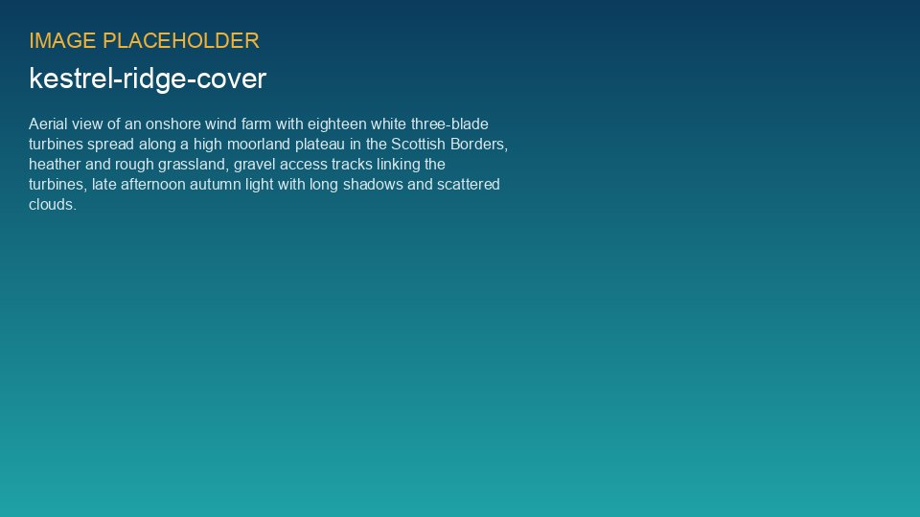
Kestrel Ridge from the south-west, October 2025

1. Key facts
Item | Details
Location | Scottish Borders, Kestrel Ridge plateau, 420–510 m elevation
Installed capacity | 75.6 MW – 18 × 4.2 MW onshore turbines (T-01 … T-18)
Turbine geometry | Hub height 95 m, rotor diameter 133 m, tip height 161.5 m
Commercial operation date | 15 March 2024
Grid connection | 33 kV collector system to on-site 33/132 kV substation; connection to the NordGrid Transmission 132 kV network
Long-term energy yield (P50) | 213.5 GWh per year (post-construction assessment, 2024)
Generation 2025 | 206.6 GWh – capacity factor 31.2 %
Availability 2025 | 97.4 % (contract target 97.0 %)
O&M contractor | Highline Wind Services – full-service agreement WE-CON-2023-015
Asset manager / site manager | David Chen / Ben Okoye

2. Site and layout
The wind farm sits on the Kestrel Ridge plateau at 420–510 m above sea level. The 18 turbines are arranged in two rows along the ridge line, connected by 14.2 km of gravel access tracks. Turbines T-01 to T-06 stand on Hartside Farm, T-07 to T-13 on the Craigmuir Estate and T-14 to T-18 on Low Swinton Farm. All three landowners continue to graze sheep on the site, which keeps the vegetation around the turbine bases short and supports the bird carcass searches.
Site access is from the B-road at Netherhall via a locked gate (code held by the site manager and the control room). The site office and welfare unit are located next to the substation compound.
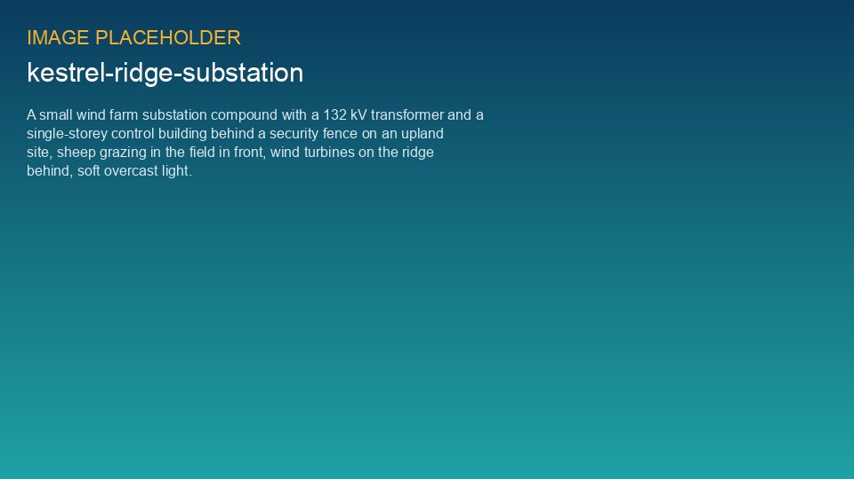
Kestrel Ridge substation and control building

3. Operating history
Date | Event
2022-05 | Construction start (civil works)
2023-10-26 | O&M contract WE-CON-2023-015 signed with Highline Wind Services
2024-03-15 | Commercial operation date (COD)
2024-06-19 | Take-over certificate after 3-month reliability run (95.7 %)
2024-12-07 | 9 h grid outage during winter storm, no damage
2025 | First full year: 206.6 GWh, availability 97.4 %
2026-01-14 | T-07 gearbox bearing failure (KR-INC-2026-003), turbine offline 23 days
2026-05 | Preventive ISS bearing replacement on T-12 (found during endoscope campaign)
2026-09-25 | Annual service campaign 2026 completed

4. Planning conditions with operational impact
- Shadow flicker: max. 30 hours per year and 30 minutes per day at any residential receptor – shadow flicker modules on T-03, T-04 and T-15.
- Ice throw: warning beacons at the three public access points, automatic ice detection and stop on all turbines.
- Noise: ETSU-R-97 limits; night-time noise-reduced mode on T-14 and T-16 between 23:00 and 07:00.
- Ornithology: post-construction bird carcass monitoring for years 1–3 (2024–2026) and annual reporting to the council.
- Community benefit fund: GBP 378,000 per year (GBP 5,000 per MW) for the communities around the wind farm, administered with the local community councils.
- Decommissioning: bond of GBP 2.9 m in place; site restoration plan to be updated in 2029.

5. Key contacts
Role | Name | Organisation
Asset Operations Manager | David Chen | Weyland Energy
Site Manager | Ben Okoye | Weyland Energy
Performance Analyst | Sara Lindgren | Weyland Energy
HSE Manager | Hannah Weber | Weyland Energy
Contract Manager | Craig Ferguson | Highline Wind Services
Site Lead Technician | Stuart Laidlaw | Highline Wind Services
Control room (24/7) | Weyland Control Centre, Edinburgh | +44 131 555 0170

In an emergency on site, call 999 first and then the control room. The site emergency response plan is in the HSE space.

